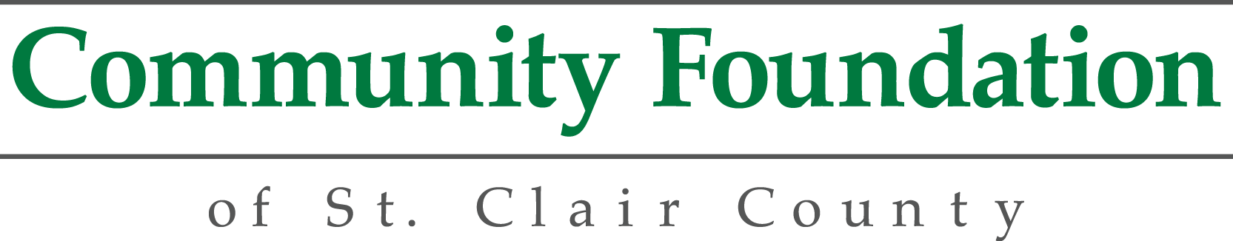

DONOR ADVISED FUND

GRANT RECOMMENDATION FORM

NAME OF DONOR ADVISED FUND:

__________________________________________________________________________________

As the Advisor to the above-referenced Fund, I recommend that the Community Foundation of St. Clair County consider the following grant (one grant per request form):

Agency Name: ______________________________________________________________________

Tax ID # __________________________________

Agency Address: _____________________________________________________________________
(street)
______________________________________________________________________
(city) (state) (zip)

Contact Name/Title: ______________________________Phone/Fax:____________________________
Grant Amount: _______________________

Purpose: (please check)
- General Operating Support
- Capital Contribution
- Specific Program/Other _______________________________________________________

Special instructions (if any): ___________________________________________________________

___________________________________________________________

_______________________________________________________________________

INSTRUCTIONS FOR USE

Please use this form when requesting a grant distribution from your Donor Advised Fund. Use one form for each grant request. Mail or fax the completed form to:
Community Foundation St. Clair County
500 Water St.
Port Huron, MI 48060
Fax: (810) 984-3394

APPROVAL PROCESS
Upon receipt of your request, the Community Foundation staff will review the form to insure that all necessary information is included and verifies that the organization is a charitable organization eligible for funding.

Requests under $25,000 are submitted to the President for approval. Requests over $25,000 but under $50,000 go to the Grants Committee. All requests over $50,000 require approval by the Foundation Board. Following approval, a grant is made to the organization. We sincerely appreciate the opportunity to be of service to you in your charitable giving and welcome your suggestions.

REQUESTS THAT DO NOT MEET IRS REGULATIONS
We appreciate the opportunity to be of service to you in your charitable giving. As a part of that service, it is important to comply with IRS regulations regarding Donor Advised Funds. In exchange for an irrevocable gift to a Donor Advised Fund, you receive a tax deduction. In order to preserve the integrity of this deduction, the Foundation cannot honor certain grant requests. Following is an explanation of requests that would not qualify.

- Personal Benefit - Donors and their immediate family members, along with related parties, and/or their advisors and/or their immediate family members, may not receive any grants, loans, compensation or any other similar payment from this donor advised fund or derive any personal benefit from a grant from this fund.

- Pledges – this request would fulfill a commitment previously made by you, a family member, advisor or related party. Relinquishment of control of the asset is essential to proving that an irrevocable gift was made. For example, control is not given up if the Foundation fulfills a charitable obligation or pledge made by the donor. The Foundation cannot be responsible for a donor’s obligation even though the obligation is to a charity.

- Grants to individuals, such as for a scholarship award, grants to private foundations and grants for non-charitable purposes.

- Expense Reimbursements - donor advised funds may not reimburse a donor, advisor, family member or a related party for expenses incurred hosting or organizing a fund raising event.

- Memberships – this request would result in a membership benefit to you, a family member, advisor or related party. There are specific IRS rules regarding the deductibility of contributions for which donors receive a benefit. For example, when an individual pays for a membership to an organization and receives parking privileges, then the amount of the membership less the value of the parking privileges becomes the deductible amount. The rules are no different for contributions to Donor Advised Funds. Since donors receive a full tax deduction when a contribution is made to a fund at the Foundation, a Donor Advised Fund may not be used to pay for memberships in which the donor receives goods or services in exchange.

- Dinners/Events – the request would result in a benefit to you, an advisor, family member or related party. There are specific IRS rules regarding the deductibility of contributions for which donors receive a benefit in exchange. For example, when an individual buys tickets to a fundraiser and receives a dinner as part of the cost of the ticket, then the amount of the ticket less the value of the dinner becomes the deductible amount. The rules are no different for contributions to Donor Advised Funds. Since donors receive a full tax deduction when a contribution is made to a fund at the Foundation, a Donor Advised Fund may not be used to purchase tickets to galas or any other type of charitable contribution in which the donor receives goods or services in exchange. Our intent is to protect the charitable deduction of your gift to the Community Foundation.

REQUESTS REQUIRING EXPENDITURE RESPONSIBILITY

Some grant requests may require expenditure responsibility by the Community Foundation of St. Clair County. These grants would otherwise be taxable. Expenditure responsibility is designed to ensure that a grant is used for charitable purposes and that the community foundation maintains appropriate oversight and documentation of certain grants from donor advised funds.

The Community Foundation of St. Clair County will follow the expenditure responsibility decision tree created by the Council on Foundations (see separate decision tree document). Currently, private foundation rules define expenditure responsibility as a five-step process that includes;
- Conducting a pre-grant inquiry including reasonable investigation of the grantee to ensure that the proposed activity is charitable and that the grantee is able to perform the proposed activity.
- Executing a written agreement with the grantee that specifies the charitable purposes of the grant and includes provisions that prohibit use of the funds for lobbying activities and requires the grantee to return any funds not used for the designated purposes.
- Requiring the grantee to maintain the grant funds in a separate fund so that charitable funds are segregated from non-charitable funds.
- Requiring the grantee to provide regular reports on the use of the funds and the charitable activity supported by the grant.
- Including a report on Form 990 (if required) about the grant including a brief description of the grant, the amount, the charitable purpose, and the current status of the grant.

I understand that this recommendation is advisory only and that final authority over all distributions made by the Foundation rests with the Community Foundation of St. Clair County, whose authority it is to ensure that all grants are made for charitable purposes consistent with Internal Revenue Service guidelines and within the mission of the Community Foundation.

The grant suggested above does not represent the payment of any personal pledge or other financial obligation of mine, my advisors, family members or party nor do we expect any direct or indirect benefit from this charitable distribution.

Signature: _________________________________________________ Date: ___________________

Modified 4/14/2016

